Business Requirements Document Template

### 1 - Background & Current Performance

Please provide a description of the current situation that needs to be changed/improved. Factual data is needed to support your business case. For example, use FBI reports, data analysis to show the impact.

### 2 - Business Problem/Opportunity Statement

|  |  |  |  |
| --- | --- | --- | --- |
| **Problem/Opportunity** | **Description** | **Criticality** | **Ventures** |
| State your problem/opportunity here | Provide a detailed description of your problem/opportunity here. | Mention how critical this is (P0, P1, P2, P3) | What ventures are  impacted by this? |

### 3 - KPIs Impacted by the Problem

List all relevant KPIs here, essentially they should impact the following performance and battle KPIs:

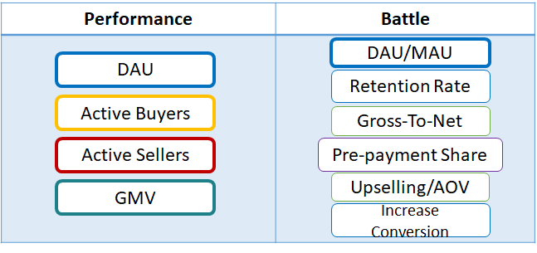

### 4 - Estimated Targets for each KPI

For each KPI defined above, please provide a measurable target i.e (actual figures) whereby performance can be measured. You may use the following format:

|  |  |  |  |
| --- | --- | --- | --- |
| **KPI** | **Current Performance** | **Expected Performance** | **Justifications** |
| State your KPI here | Mention the current/avg performance | Mention the targeted performance | Explain on what basis these targets have been calculated, e.g. benchmark from Lazada’s performance / historical data |

### 5 - Provide Business Stakeholders

Please define the relevant stakeholders from business that need to be involved in this project. You may use the following format:

|  |  |  |
| --- | --- | --- |
| **S. No** | **Business Department** | **PIC** |
| 1. | Mention the department here | Add the relevant team member(s) to be involved |